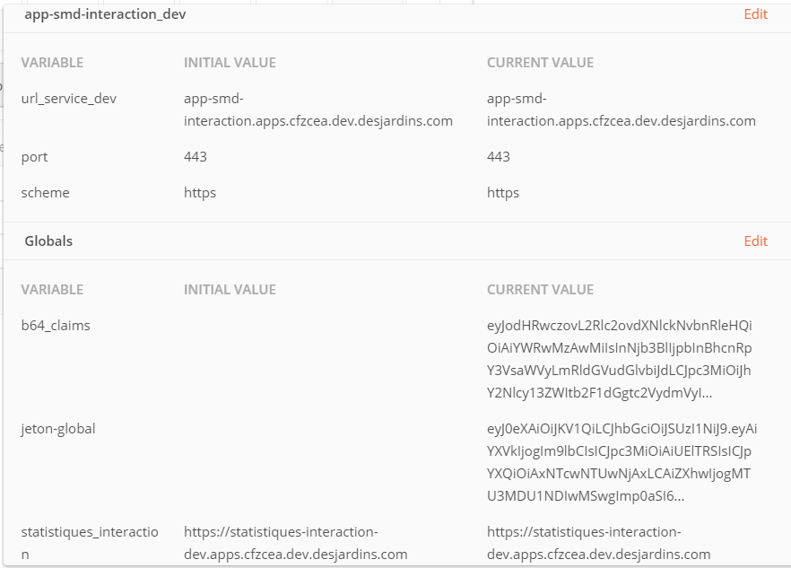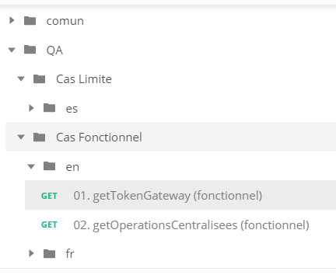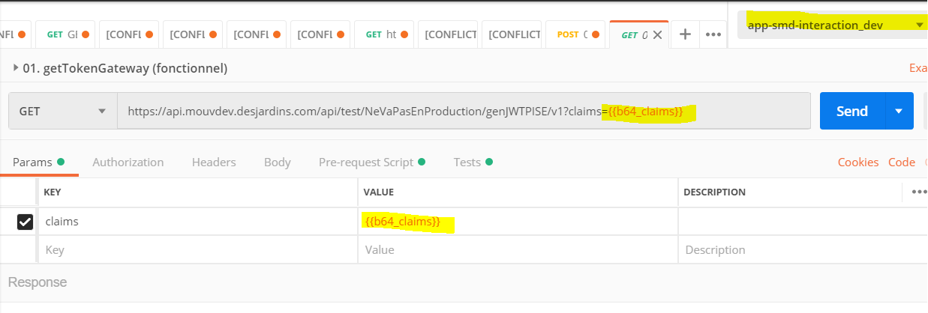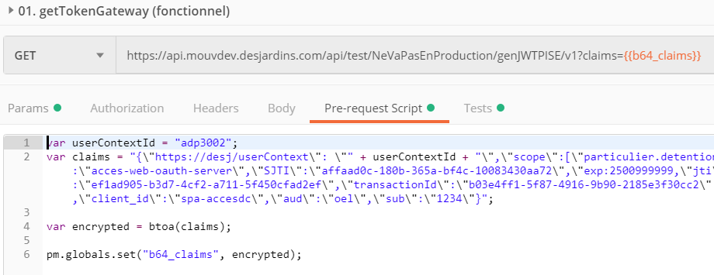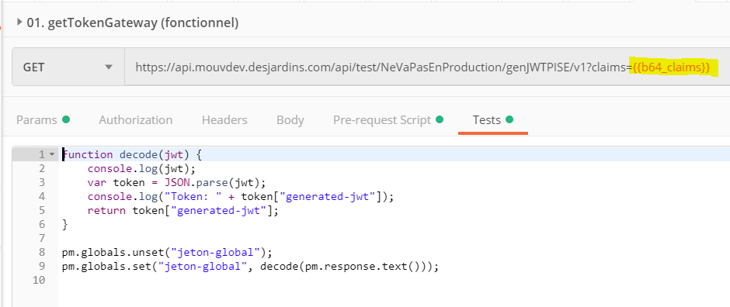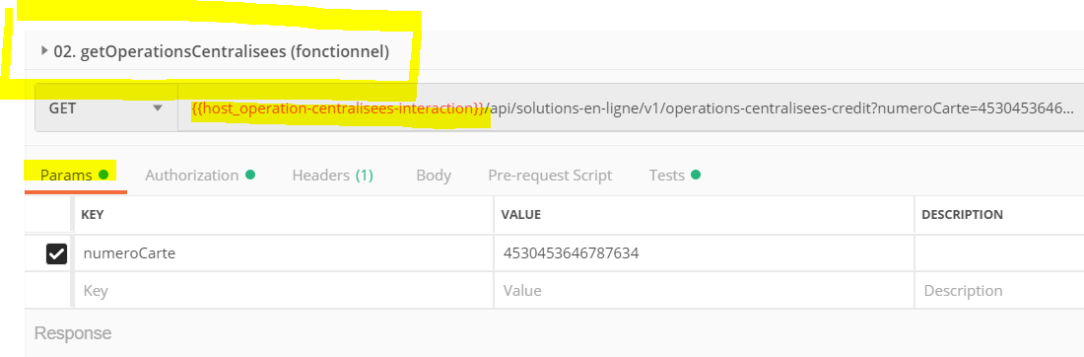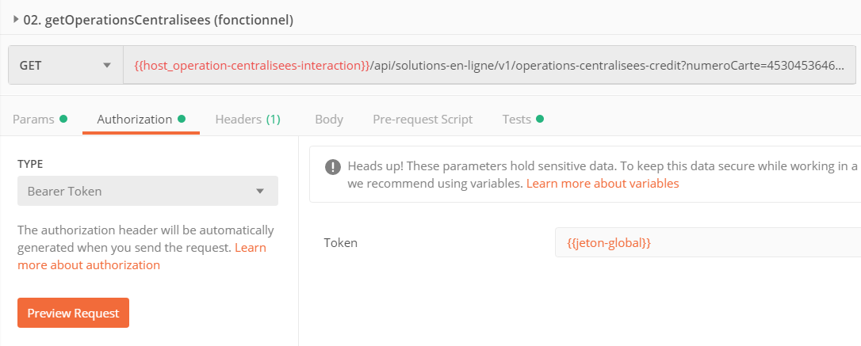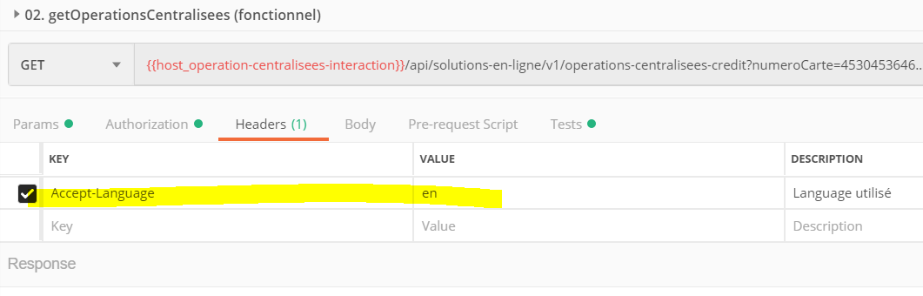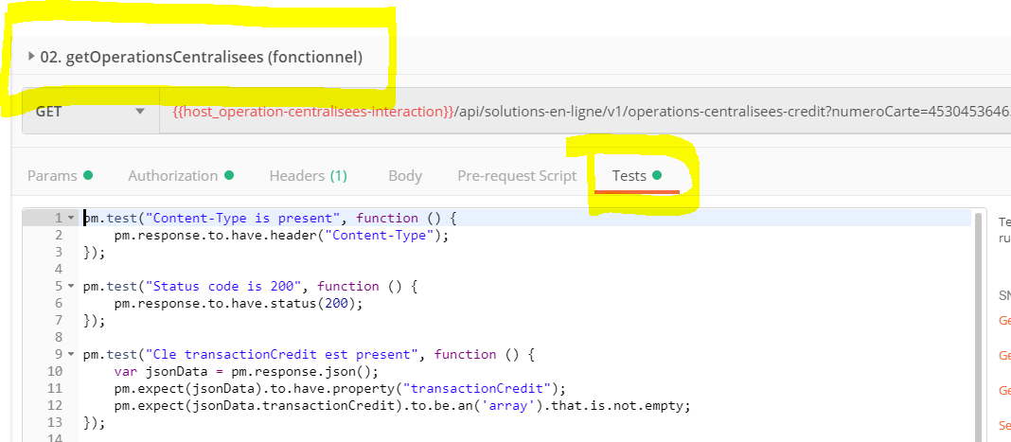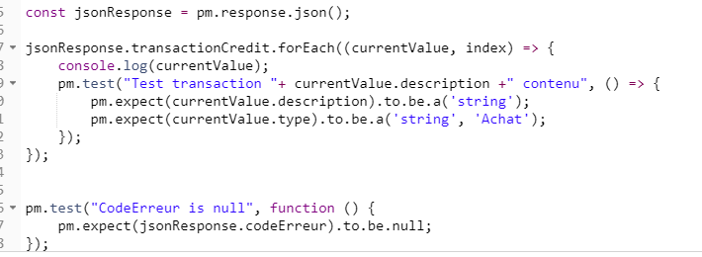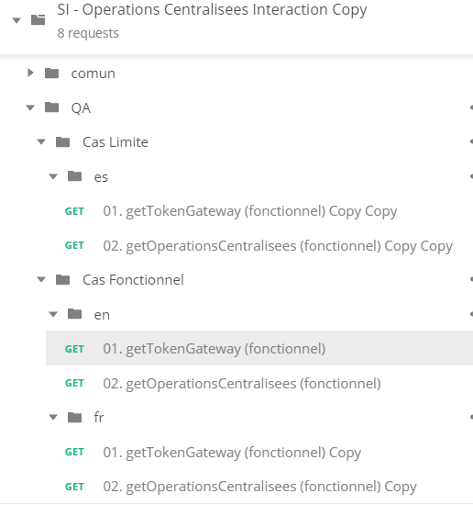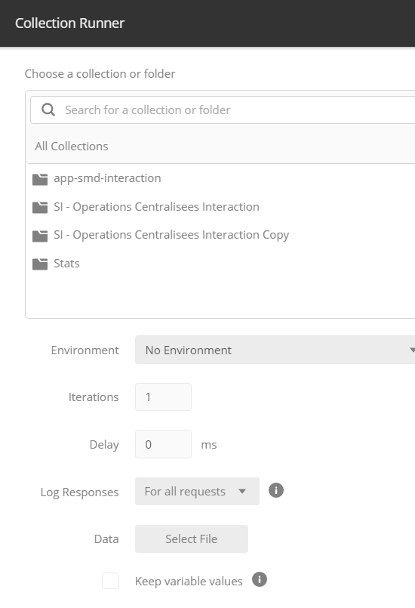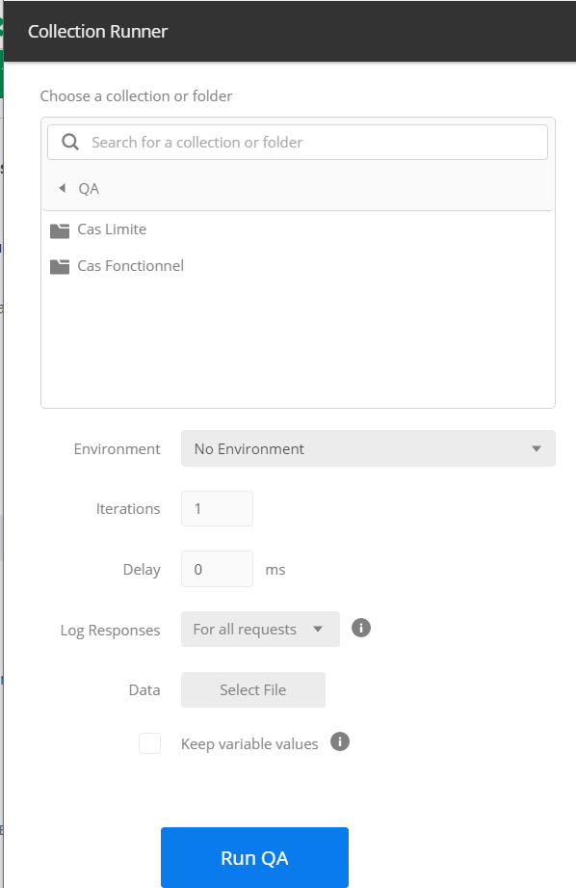

GUIDES

<https://openclassrooms.com/fr/courses/4668056-construisez-des-microservices/5123020-testez-votre-api-grace-a-postman>

<https://www.udemy.com/fr/topic/postman/>

<https://support.brightcove.com/fr/use-postman-api-requests>

<https://blog.webnet.fr/presentation-de-postman-outil-multifonction-pour-api-web/>

<https://www.youtube.com/watch?v=juldrxDrSH0&list=PLhW3qG5bs-L-oT0GenwPLcJAPD_SiFK3C&index=1>

JAVASCRIPT

https://www.youtube.com/watch?v=wXOxtKLN5tk

https://www.udemy.com/course/javascript-es6-es7/?gclid=EAIaIQobChMIhvr24tmk5QIVCmyGCh1sDA43EAAYASAAEgKzkfD_BwE&moon=iapetus&utm_campaign=20180605-French-Quebec&utm_medium=udemyads&utm_source=adwords-intl&utm_term=_._ag_65060695822_._kw_javascript+cours_._ad_377036741999_._de_c_._dm__._pl__._ti_kwd-654317686011_._li_9000555_._pd__._

